All mosquito traps from summer 2017. Abundance standardized for time (3.5 hours)

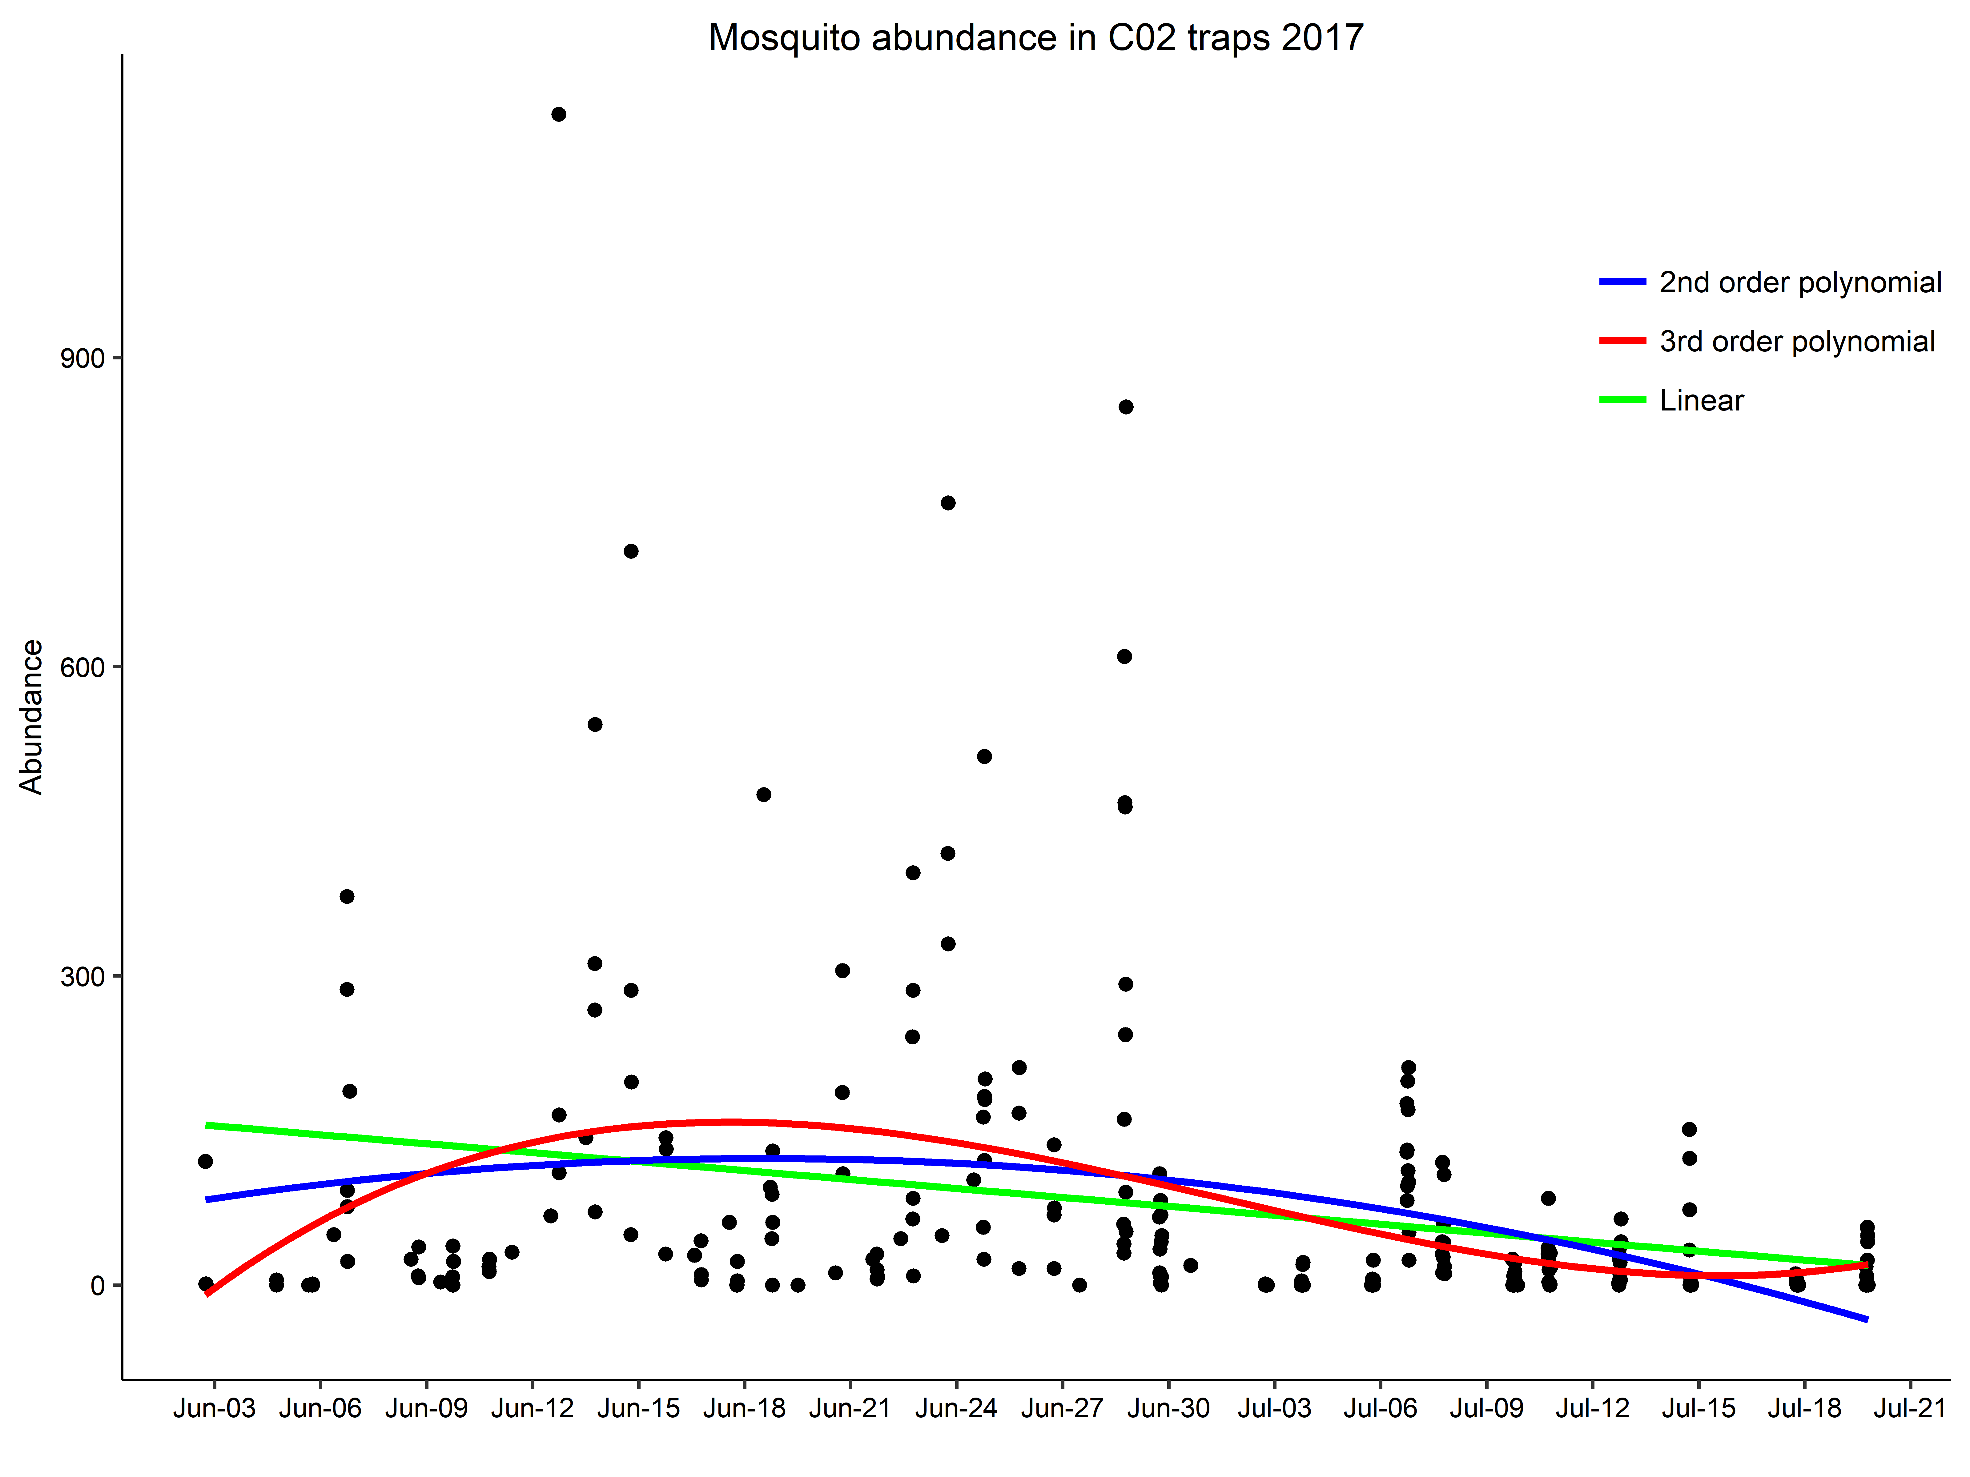

How does mosquito abundance change across 1) Time 2) Daily weather 3)

Datasubset, trapping times with AT LEAST 4 traps on at the same time

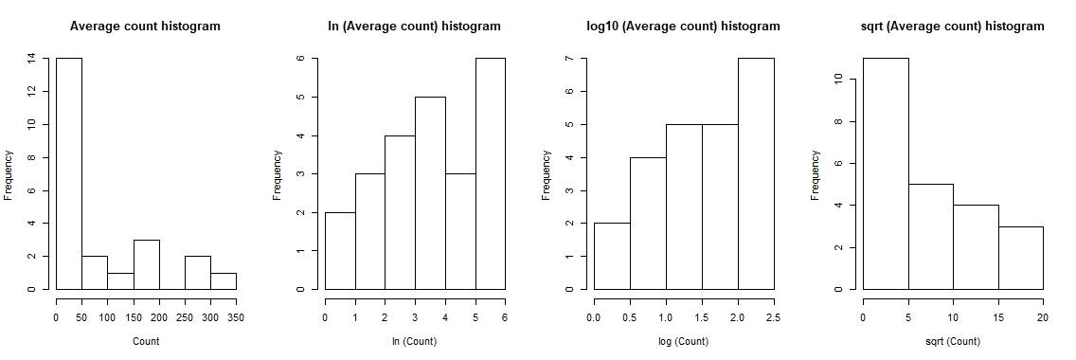

Count data follow a zero inflated neg binomial distribution (second best neg. binomial)

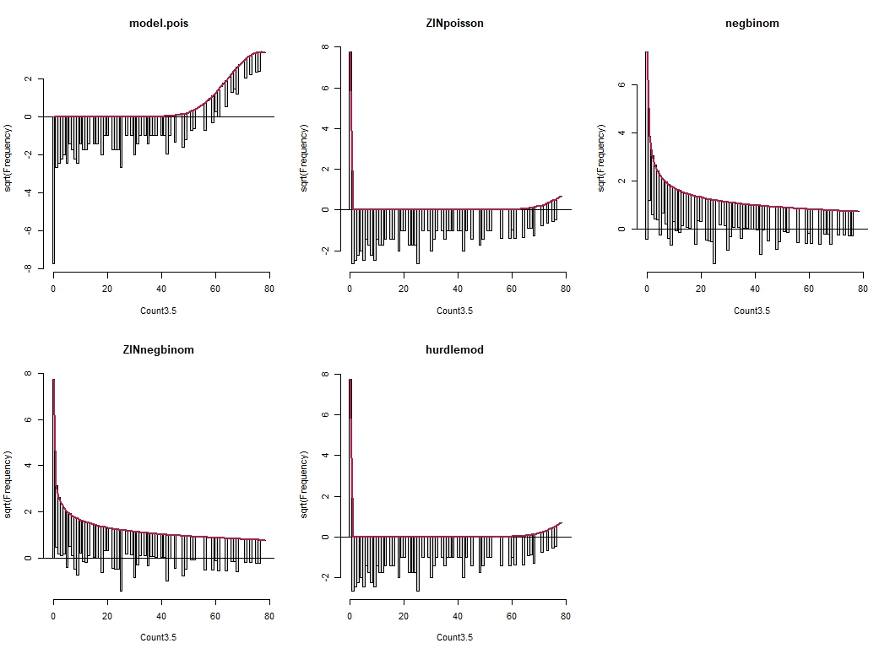

aictable(rawaic,nR)

Params logL AICc deltaAICc weight cumwt

ZINnegbinom 3 -1196.255 2398.605 0.0000 0.88 0.88

negbinom 2 -1199.271 2402.591 3.9856 0.12 1.00

null 2 -1627.648 3259.344 860.7390 0.00 1.00

hurdlemod 2 -16426.906 32857.859 30459.2542 0.00 1.00

ZINpoisson 2 -16426.906 32857.859 30459.2542 0.00 1.00

model.pois 1 -21582.176 43166.367 40767.7620 0.00 1.00

Average counts across the 4+ traps over 3.5 hours. Red = spline 3 knots, Blue = spline 4 knots

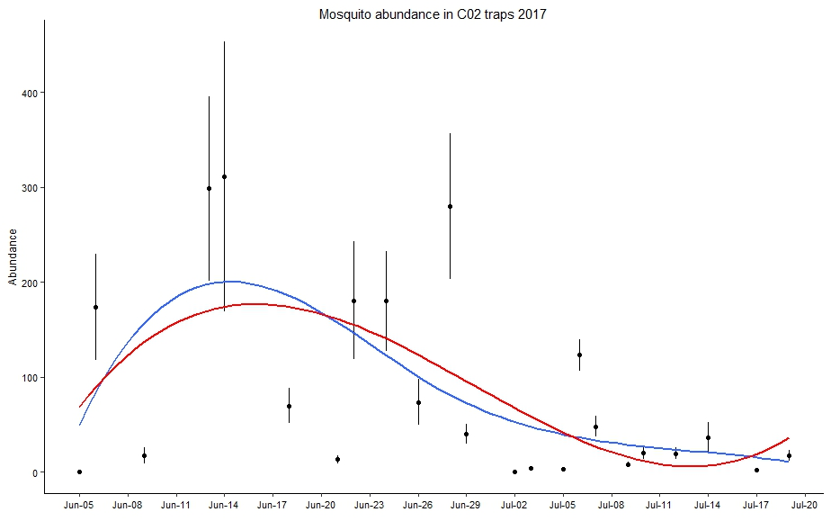

Same thing on a Ln scale

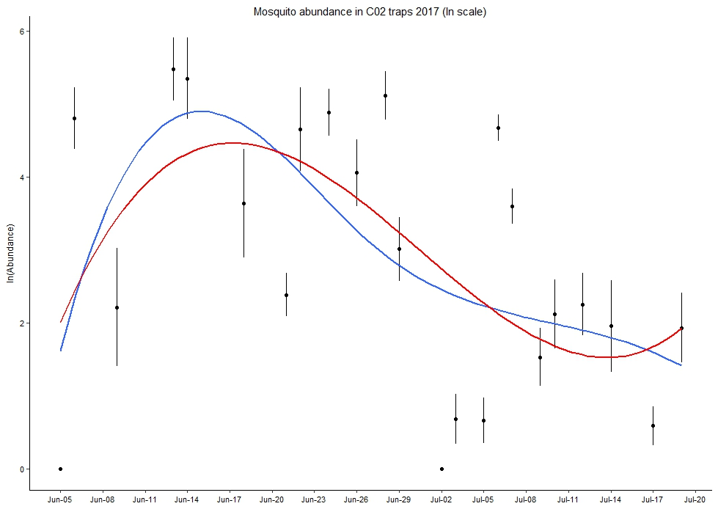

Extracted weather data from weather stations during trapping times.

Frequency histograms of weather variables during trapping times

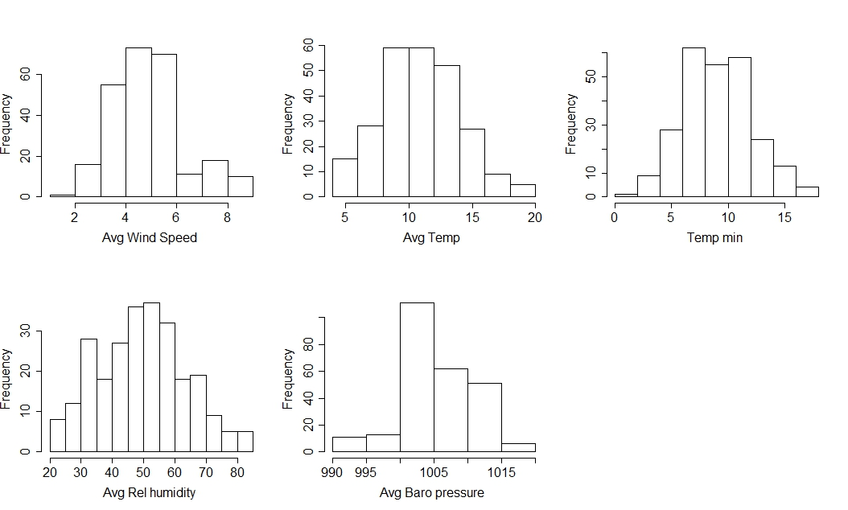

Correlations between weather variables (RH and temp are correlated, everything else looks okay)

